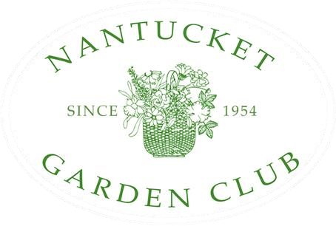

Thank you for visiting Ms. Moby, the Whale
A Gift to the community from
the Nantucket Garden Club!

Since 1954, the Nantucket Garden Club has contributed to the beauty of Nantucket and supported conservation initiatives to protect the island's fragile and historic environment.

Current projects include:
- scholarships to local students pursuing environmental studies
- the annual Daffodil Show, daffodil bike path planting and school daffodil bulb distribution
- funding the fifth-grade tree planting project
- maintaining the period garden at Hadwen House
- creating the floral arrangements at the Main Street Fountain
- providing grants to island non-profits including Maria Mitchell, Sustainable Nantucket, Nantucket Conservation Foundation, Small Friends, Lighthouse School, Nantucket Community Garden and the Nantucket Cottage Hospital

The Nantucket Garden Club's largest fundraiser is the Annual Home and Garden Tour, scheduled to return on August 3, 2022! We hope to see you there!

www.nantucketgardenclub.org

